Further Examples — Limits Inferior and Superior

Christian Jones: University of Bath

November 2022

Table of Contents

# Overview

In this document, you’ll find three different examples of finding the limit superior () and limit inferior () of a sequence, with different methods used in each case.

## Example 1

Example 1

Consider the sequence defined by

Find and .

**Solution** Firstly, note that we can rewrite each as

Splitting into odd and even cases, we obtain

Note that for , . Also note that is a decreasing sequence and is an increasing sequence [Try showing these!] Moreover, , so is bounded.

Now, fix . We have:

Hence, taking , we find that . So, .

Similarly, fixing again:

Hence, taking , we find that . So, .

In case you’re interested, the first 100 terms of the sequence looks like this:

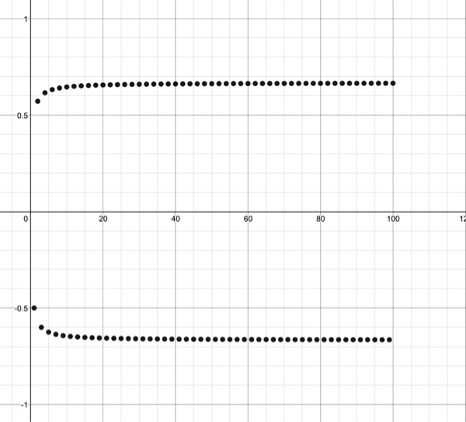

## Example 2

Example 2

Consider the sequence defined by

Find and .

**Solution** First, note that for any , . But this time, we find that both and are decreasing sequences! In this case, the argument used in Example 1 will only work for Try using that argument to show that

For , we have to look towards the start of the sequence. To this end, fix . Then,

In both cases, as , , so .

## Example 3

Example 3

Consider the sequence defined by

Find and .

Note that this time, you can’t split up into two monotonic subsequences, so neither of the two methods in the previous examples work. So, we need to be crafty.

It’s always handy to have an idea of what the and might be. Since for all , and as , we (hopefully) would guess that

So how do we go about showing these?

Firstly, recall that the is the largest limit of any subsequence of . Take , then

So, , hence .

To show that , recall that for sequences and ,

Taking

we have that

Hence,

Combining the two inequalities we have found allows us to conclude that

Have a go at proving that . You’ll need:

* is the smallest limit of any subsequence of .